**Task Force Spartan**

**Armored Convoy Halts & Dismounting**

It is a good idea to avoid staying mounted as passengers in them, due to the risk of a single RPG wiping out the entire vehicle, its crew, and the immediate family and close friends of everyone who was embarked on it at the time.

When dismounting, infantry elements should provide 360° security as a standard. They should also try to get at least fifteen meters of clearance from the vehicle to help protect against primary or secondary explosions in the event that it is engaged.

Moving on, let's look at the various other considerations that must be made regarding halts and dismounting from vehicles.

When to dismount?

To help decide on when to dismount, versus when to stay mounted, follow these basic guidelines.

* If a halt is short duration (30 seconds or less), mounted troops typically stay in their vehicles. All personnel continue to scan around the vehicle and stay alert to any potential enemy threats.
* If a halt is longer duration, mounted troops dismount and provide local security. Team leaders and squad leaders will order the dismount, at which point the "Dismount Drill" procedures are conducted. When it comes time to remount and move out, team leaders and squad leaders will say "Remount", "Mount up", or some variation thereof, which will then be repeated by everyone in earshot over direct-speaking comms. Each team leader will maintain accountability of their men each time they dismount and remount to ensure that nobody is ever left behind.
* Regardless of the duration of a halt, the driver and gunner always stay mounted. The only time they will leave the vehicle is if it is disabled or destroyed. The gunner may also dismount if the vehicle gun is out of ammo, so that they can employ their personal weapon.

5 & 25 Scan

A "5 & 25" scan involves scanning the area immediately around you and the vehicle for five meters, then dismounting and scanning for 25 meters in all directions. The idea is to ensure that the vehicle did not stop near a concealed satchel charge, mine, or enemy. The tactical situation will determine how much time you have to spend on this scan. At the very least, upon dismounting, ensure that you do a hasty 360° threat scan. Ensure you check all of the concealment-offering objects - such as bushes, brush, etc - around you as time permits. A well-camouflaged enemy will be extremely difficult to detect.

Note that due to the peculiarities of how Arma models armor and vehicle protection, the "5 & 25" scan often becomes "get out of the vehicle FIRST and scan afterward", instead of the more real-world procedure of scanning the first 5 meters while still mounted. In reality, being mounted in an armored vehicle provides a very large degree of protection. In Arma 3 this can depend heavily on the armor of the vehicle and the potential explosives used, so it can be a judgment call as to whether you'll want to dismount first or not.

Dismount Drill Procedures

The 'dismount drill' is a standard set of procedures that are executed upon dismounting a vehicle. While they can differ somewhat based on the tactical situation (ie: under fire or not), the same concepts apply at all times.

If dismounting under fire...

* Dismount once the vehicle has come to a halt or is moving slow enough that exiting will not injure you. Always Dismount to the side that isn't taking fire from the enemy positions
* Immediately return fire on known or suspected enemy positions while moving to a position that offers cover or concealment. If no cover or concealment is available, either use the vehicle as cover, or take a lower stance.
* Begin the "React to Contact" battle drill and follow it until directed otherwise.
* If the situation allows, conduct a hasty "5 & 25" scan, as described above. Ambushers will often try to get vehicles to stop in an area that has been mined or otherwise booby-trapped.

If not under fire...

Dismount once the vehicle has come to a halt.

* Move away from the vehicle to a position that offers cover or concealment. If unavailable, take a knee or go prone to reduce your exposure.
* Conduct a deliberate "5 & 25" scan, as described above.
* Scan outward and identify likely threat avenues, key terrain, etc.
* Continue scanning the surrounding terrain for enemy threats until ordered to remount the vehicle or move out with your team leader.

Bear in mind that this same dismount drill can be used when exiting a helo or any other vehicle where you may need to immediately fight or form a perimeter and provide security.

The decision to dismount can be a command from a leader or on your own disciplined initiative. If given as a command, it will be "Dismount, dismount!". Individual initiative is important here, of course. Don't sit in a vehicle getting shot up if you know you should be dismounting to react to the threat on foot!

Do not say "BAIL OUT!" when ordering an infantry dismount! "BAIL OUT" will cause the entire crew to exit the vehicle as well, and should only be used if the vehicle is in imminent threat of being completely destroyed.

Situational Awareness

Everyone in a vehicle must scan their sectors to maintain situational awareness at all times. Vigilance will help to spot enemy ambushers and spoil their element of surprise. The sector a person scans will depend upon where they are placed in the vehicle. For an MRAP, basic sectors are depicted below. 360° coverage is the ultimate goal.

Convoy Operations

Speed is Life, but Cohesion is Important

Speed in a convoy tends to result in security. This is due to the fact that speed makes it harder to engage the vehicles with threat weapons such as RPGs, command-detonated explosives, and more. However, one must be careful to balance speed with cohesion - if a convoy is spread out too far, the mutual support of each vehicle's weapons, and the security they bring, is lost. This leaves individual vehicles subject to the massed fires of the enemy, which can cause a lot of trouble in short order.

To maintain convoy cohesion, the first vehicle must be aware of their speed and the proximity of those behind them. The convoy commander and other vehicle drivers can facilitate that situational awareness by communicating with the lead vehicle and other vehicles, giving them guidance on their speed, interval, sectors of observation, and more.

If the lead vehicle needs to unexpectedly brake hard for some reason, the driver will say "BRAKING, BRAKING, BRAKING '' loudly over comms to help to prevent the trailing vehicles from piling into them when they slow down.

**Interval**

Maintaining good intervals is a key aspect of multi-vehicle operations. Depending on the terrain, vehicles should keep from 20 to 100 meters of spacing between each other. This helps to lessen the effects of enemy explosives such as satchel charges and IEDs and makes it harder for the enemy to mass fires on multiple vehicles at once.

It is particularly important to maintain good intervals when stopping temporarily, taking corners or other types of turns, and halting the convoy.

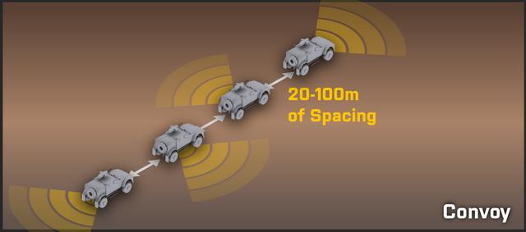

Route Selection & Actions-On

Avoid urban areas whenever possible. It is far too easy for an enemy force to set up a devastating ambush in an urban area. Routes which pass through heavily wooded or extremely rocky areas are likewise dangerous, but due to the nature of some terrains, they cannot always be avoided. Caution is the prime defense in that case.

The convoy must know where to go, and must be planned out in advance with backup courses of action. If every driver knows the path they're supposed to take, and what the end goal is, they are able to better make tactical decisions and judgment calls in high-stress situations.

The convoy must know actions-on. If the vehicles take contact, the drivers must know what they are supposed to do. In some situations it will be important to maintain high momentum and fight through every ambush or contact with ferociously aggressive action, while others will benefit from a more deliberate approach which involves clearing each contact with the help of dismounted infantry. It is up to the convoy commander to ensure that actions-on are briefed before the convoy starts rolling.

Situational Awareness & Security

Gunners must cover appropriate sectors. The first vehicle in a convoy watches to the front, the last vehicle watches to the rear, and vehicles in between alternate left-right-left so that guns are pointed in all threat directions at all times. It is important that gunners maintain their 360° observation even when contact seems to primarily be coming from a specific direction - if not, it is easy for the enemy to exploit this and maneuver into or fire from unobserved areas while the gunners are distracted elsewhere.

Cohesion and security at halts are critical. Maintaining a cohesive formation and using good security procedures are critical to convoy survivability. If a full halt must be conducted, dismounted infantry must be employed to keep the convoy safe while halted. Cohesion is just as important, as it masses friendly forces and makes it much more difficult for the enemy to endanger the convoy.

Actions on…

Contact - Push Through

If ambushed, our standard procedure is to fight through it while mounted and not stop until we have exited the kill zone. If the enemy begins firing on a convoy, all gunners should immediately bring their weapons to bear and put out a heavy volume of return fire. Even if the gunners cannot see the enemy, they need to be firing in the direction that they are taking fire from. Once an ambush is initiated, the lead vehicle driver needs to be particularly vigilant in their scanning of the road. The odds of an IED or other explosive being placed in the path is extremely high, and it will require split-second timing to avoid such devices.

Pushing through is the default action on ambush. Leaders can also emphasize this by stating "Push through!" upon making contact.

Contact - Dismount & Assault Through

The alternate method of dealing with contact as a convoy is to assault into the contact. This is done with the verbal command of "Assault through!". When this order is given, troops dismount while vehicle gunners lay heavy fire onto the enemy positions. The dismounts and vehicles then proceed to maneuver towards the enemy and decisively engage and destroy them. When the enemy has been defeated, troops remount and continue on with the mission.

Note that when assaulting through, the infantry and vehicles are still ultimately interested in continuing on the convoy. They have some freedom to maneuver off of the convoy route to take the fight to the enemy, but they do not want to get pulled too far away.

Disabled Vehicle

Most of the types of damage that can result in a disabled vehicle cannot be worked around in Combat. Because of this, our standard procedure for a disabled vehicle is for the other vehicles to drive around it, halt in a safe area (out of the kill zone, if it's an ambush), and recover the vehicle crew if they're still alive.

It is up to the crew of the disabled vehicle to get out of their vehicle and fight their way to friendly forces. Stopping more vehicles within an ambush kill zone would only result in casualties and more disabled vehicles.

When a vehicle is disabled, anyone who sees it states "Vehicle down!" on comms to indicate it.

**Canalizing Ground**

Canalizing ground is any sort of ground in which vehicles are heavily restricted in how they maneuver within it. When this sort of terrain is encountered, infantry are dismounted to move ahead and sweep the area before the convoy is committed to moving through it. It is important to keep the dismounted infantry within range of the supporting fires of the convoy vehicles while conducting this sweep, too.

**Convoy Halts**

When halting a convoy, simply stacking the vehicles up on the road one-after-the-other is not the ideal way to do things. While this can be used for very brief halts, the better choice for reaction-to-contact or longer-duration halts is either the Herringbone formation (preferred, as it's the easiest to do) or the Coil formation.

Note, of course, that infantry should conduct dismount drills and provide local security whenever convoy halts are made, as described previously.

Herringbone Formation

The standard formation to use when halting a convoy is known as the "Herringbone". In this, the vehicles pull off to both sides of the road in an alternating manner - the first vehicle pulls off to the right, second to the left, third to the right, and so on. The vehicles stay angled at about a 45° angle relative to the road. This formation is easy to execute and allows for the convoy to get good security when halted while also spreading the vehicles out a bit more than otherwise. This formation can be used in open terrain as well, in which case the direction of movement becomes the "road" and vehicles move relative to it.

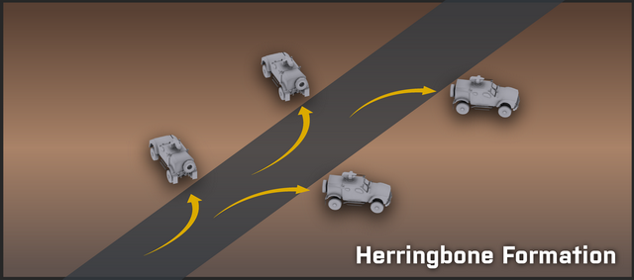

Coil Formation

The other formation that can be used is more geared towards armored vehicles. When executing a "Coil" formation, the lead vehicle stops and faces forward, the second vehicle pulls to the left and faces left (angling their strong frontal armor to the left), the third vehicle pulls to the right and faces right, while the trail vehicle turns around or spins in place so that it is oriented towards the rear. This allows for the vehicles to place their strongest armor in the direction that they're covering and provides excellent 360° security.

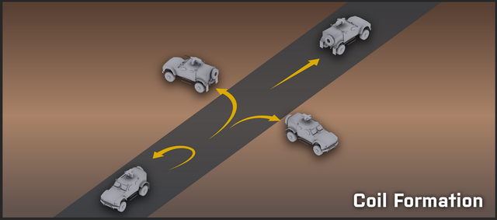

Armor & Infantry

Armored vehicles are powerful force multipliers in the combined arms battle. When properly employed with the support of infantry, the combination is difficult to match.

Being familiar with and knowing how to work with armor are critical skills for infantry and vehicle crews to have.

Coordination

An armored vehicle without infantry is vulnerable, just as infantry without armored support are vulnerable.

When in close terrain (such as dense woods or urban environments), it is beneficial to have infantry dismounted and moving on all sides of the armor. Infantry should lead the armor in such a situation, to prevent the armor from stumbling into an anti-armor trap or ambush.

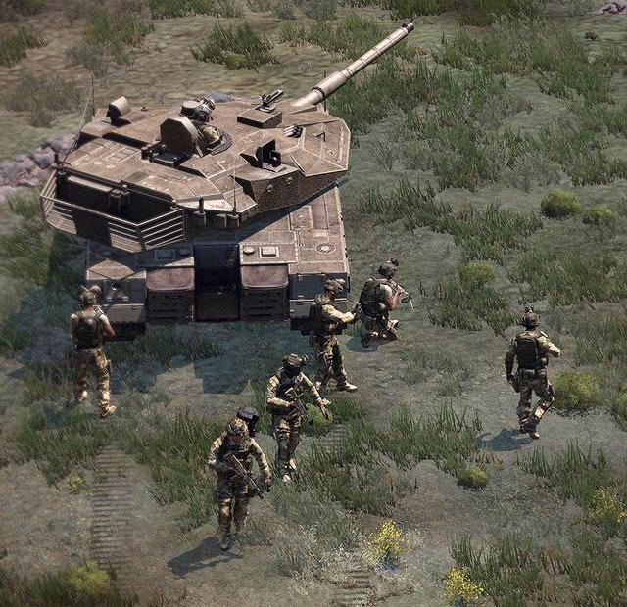

Armor/infantry coordination in close terrain requires a great deal of communication back-and-forth. Armor needs to know where the friendly infantry are, where the enemy is, while infantry need to communicate to the armor where it should move, whether there are any friendlies close to the armor (perhaps in its blind spot), where they suspect the enemy to be, and so on and so forth.

Infantry bring the following benefits to armored vehicle crews when employed together.

What Infantry Provide to Armor

-Dispersed eyes-on-the-ground which can stay alert for threats such as:

-Enemy anti-tank threats - AT gunners, cannons, deployed ATGMs

-Enemy armored vehicles

Mines, satchels, and IEDs

-Ability to spot targets without exposing the armor, and then direct the armor's movement and fires to kill the targets efficiently.

-Protection in close terrain.

-Guiding movement in close terrain.

Helicopters & Infantry

Helicopters provide infantry with both transportation and fire support. They are the most tightly-integrated air asset available to ground troops and act as a major force multiplier.

Helicopters are commonly employed in a support role, and all players are expected to be familiar with their employment in the combined arms fight. That familiarity begins with knowing the pros and cons of their combined arms role.

Pros & Cons

The pros and cons of helicopters in the combined arms role are as follows.

Pros

Observation. Helicopters are great at reconnaissance and security. This is in part due to their relatively low speed and the low altitude that they operate at, combined with observation pods on many of the most common helicopters employed.

Insertion/extraction capability. Helicopters can airlift troops and drop them at will nearly anywhere they want. This allows for great flexibility in planning operations.

Orbit capability. A helicopter can stay "on station" over the ground forces it is supporting with ease, due to the dynamics of helicopter flight as compared to what jets are able to do. A helicopter that is orbiting over friendly forces is available to provide support in the form of machine guns, cannon fire, rockets, ATGMs, or observation, depending on the variant and armaments.

Rapid reaction to Close Air Support requests. Due to the ability to orbit as described previously, a helicopter acting in a CAS role can rapidly react to any support requests made. This reduces the time between a CAS request being made and rounds landing on target. This, in turn, makes it more likely that the CAS will be able to suppress or kill the enemy threat before it can do harm to friendly forces.

Precision CAS. Helicopters can be very precise in their employment of fires, due to speed, altitude, magnified optics, the capability to hover, et cetera.

Stealth. Helicopters can get low to the ground and can hide in terrain in a fashion similar to ground vehicles or even infantry. They can transport troops in a concealed fashion, as well as sneak around in a combat capability, popping up into view only when they're ready to kill something.

Cons

More vulnerable to most threat weapons. Helicopters can be taken down by a wide range of weapon types if they're not carefully employed. They fly low and slow relative to jets, and transport variants can be very vulnerable when flying into or out of a landing zone.

Weaker armament than jets. Helicopters cannot lift as much ordnance as jet aircraft, meaning that they almost never have anything that can pack the same kind of punch as a 500lb or 2000lb bomb from a jet. However, they make up for this with the precision of their fires.

Loud. The enemy will definitely hear helicopters coming in, unless in the midst of a major battle.

Airborne Assaults

An airborne assault is simply an assault which uses helicopters to move the infantry into position. Airborne assaults are planned by the highest leadership element in game - usually the Platoon or Company Commander in a cooperative environment.

Planning the Assault

Landing Zone (LZ) Considerations

The first thing that must be considered for an airborne assault is where the landing zone(s) will be. Things like equipment loadout, force composition, main objectives, etc are typically done on the mission-makers side, so they are not generally planned for at the platoon level. The platoon gets the orders [in the form of a mission operation order] and acts on them.

When choosing a landing zone, the following must be taken into consideration. In short, you use METT-TC and OCOKA, but specific emphasis is made on the following elements of it.

Terrain. What kind of terrain is around the objective? Is it hilly, flat, mountainous, etc? Flat terrain makes LZ selection difficult and generally forces you to land further from the objective. Hilly, rough terrain can allow for a closer LZ to the objective, but makes it harder to find a good LZ to set down at - which increases the usefulness of being able to drop troops without setting the helicopter down.

Approaches. Being able to approach the LZ and never come into visual view of the enemy is highly desired. If they cannot see you, they cannot hit you with direct-fire weapons, and you may be able to confuse them as to your precise landing spot. Terrain depressions, hills, and even forests can be used to mask the helo on the approach.

Cover/Concealment availability. Once the troops are on the ground, what kind of cover and concealment will they have? The more the merrier. At the same time, landing in an area with too much hard cover can be tricky for pilots, increasing the risk of damaging the aircraft.

Proximity to the enemy. The closer you try to land to the enemy, the riskier things get. While 'hot' landings can be done, they require the element of surprise to be effective, and benefit greatly from CAS and artillery fires being used to suppress or otherwise occupy the enemy during them.

Likelihood of patrols. The more likely enemy forces will be patrolling far out around the objective, the further the LZ should be, or the more the LZ should be prepped (by artillery or CAS) before the landing occurs.

Enemy anti-air capabilities. If the enemy has MANPAD missiles or Tigris AA vehicles, a masked approach becomes critical. If that is not possible, the LZ must be far enough away from the enemy that there is no reasonable chance of being engaged by the enemy anti-air at or near the landing zone.

After the primary LZs are chosen, a set of alternate LZs should be determined based on the possibility of enemy contact at the main LZs. Alternate LZs should typically be positioned 500 or more meters further away from the expected enemy positions than the primary LZs, as an additional safety measure.

Coordination

Once the LZ(s) and alternate LZ(s) are decided on (and clearly marked on the map), the next step is to coordinate the overall assault. At this point, the following needs to be hashed out.

What squads will be in what helos? As soon as this is known, the squad leaders will oversee the embarkation of their troops into their assigned helos.

What helos will go to what LZs, and in what order will they fly? Establishing an order of flight is critical if one wants to get to the LZ in any sort of organized fashion.

What is the planned route to the LZ? High/low alt, terrain following, etc. Mapping out the route with map marks is always useful. Note that pilots can use the 'vehicle' channel to place detailed waypoints on the map for their own reference during flight. When time is available to do this, it should always be done, as it greatly reduces the workload on the pilot/navigator and allows them to concentrate more fully on situational awareness.

What order will the helos land? Simultaneously, staggered? Are waves necessary?

Simultaneous. A simultaneous landing is when all aircraft hit the LZ within about fifteen seconds of each other. This puts a lot of boots on the ground very rapidly and forces any defending forces to split their fires between multiple helicopters. Simultaneous landings typically cover a decent stretch of ground, which further dilutes the effectiveness of any defensive enemy fire. The number of guns on the helos also helps to suppress the landing zone on the way in, and provides support on the way out.

Staggered. Staggered landings occur when helicopters hit the LZ one after the other, with 30 seconds to a minute or more between each landing. This allows one squad to get on the ground, establish the security of the LZ, and provide coverage as the next helo comes in. Staggered landings are sometimes forced by the terrain - if there is only a small LZ in a clearing that is suitable for landing, you may not be able to orchestrate a simultaneous landing.

Waves. Waves occur when the number of helicopters available cannot airlift the entire assault force in one go. The key characteristic of wave landings is that the initial force will be alone on the ground for as long as it takes for the aircraft to return to the staging area, pick up the next wave, and fly them in. If the enemy becomes aware of the fact that waves are being used, they are likely to try to ambush successive waves. It is important to not become predictable in flight path/ingress directions when using waves.

What are the responsibilities of the various squads and fireteams upon landing? Each squad needs to know where to go immediately upon landing so that they clear the LZs as quickly as possible and provide security for the assault force. Security must be given high-priority consideration, as it is critical to the success of getting all friendly infantry onto the ground safely. Each fireteam should know what area of responsibility it has, and the squads should be given clear orders regarding what areas they are responsible for covering at the landing zone.

At the Landing Zone

Assuming that none of the above-listed contingencies happen (downed helo, heavy contact, emergency landing), the following steps take place at the landing zone.

The helo comes into range of the LZ and prepares to land. Speed and altitude drop accordingly. It is important that the pilot's approach is smooth and fast, as it minimizes the amount of time the embarked troops are in a vulnerable position.

The door gunner and crew chief scan the LZ area and suppress any contacts as necessary. The helo crew scans vigilantly to ensure that the helo is not about to set down into an ambush. If they see anything suspicious, they immediately report it to the pilot.

Helo touches down at the LZ.

Pilot announces "Go, go, go!" loudly, which the senior infantry leader on the helo repeats. It is important to let the pilot make this announcement, since they are the one that knows whether or not the landing is complete. "Jumping the gun" and hopping out too soon can result in rather nasty falls.

Upon hearing "Go, go, go!", all infantry immediately dismount, and the door gunner and crew chief hold fire to avoid hitting any dismounting infantry. The door gunner dismounts after their fellow infantry are safely out. Note that when disembarking, every player should avoid crossing the door gunners' lines of fire if possible. Even though the door gunner and crew chief are supposed to hold their fire when troops are debarking, there may be times when they have to risk it and fire anyway. Obviously, running in front of something like an M134 can end your day in a real harsh way. To play it safe, players should do their best to avoid crossing the lines of fire of the door gunner and crew chief. As a door gunner or crew chief, you should exercise a great deal of caution when firing in the five seconds after touchdown during which the troops are disembarking and moving out.

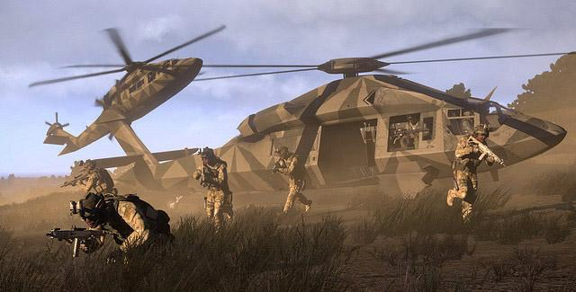

Senior element leader (ie: squad leader) oversees the dismounting process. They step away from the aircraft a few paces, take a knee if possible, and watch the passenger section of the aircraft.

All infantry immediately head to their assigned areas. A typical squad insertion involves the fireteams spreading out on either side of the landing zone to provide 360° security. Each fireteam moves away from the aircraft, spacing out and orienting outward to defend against any nearby threats. If hard cover and concealment is around, the infantry naturally integrate it into their movement and defensive plans.

When no troops are left on the helo, the senior element leader tells the helo pilot that ground forces are clear of the helo. The crew chief is also observing the cargo area and will tell the pilot as well - either can be used as the signal for lifting off.

The helo takes off. Upon hearing that ground forces are clear, the crew chief resumes firing suppression of any enemy forces around the LZ. The pilot then begins their post-insertion mission, which oftentimes is that of aerial reconnaissance and support.

Extractions

Getting troops on the ground is only part of the problem. Oftentimes they will need to be extracted as well - sometimes from a clear LZ and sometimes from the midst of a heated firefight.

Helo extractions can take several forms. At the highest level you have a full multi-squad extraction of all friendly elements that requires several helos to achieve. At a lower level you may see an extraction of something like a scout/sniper team, forward observer, or other small element.

The main point for the infantry on the ground is to do everything they can to minimize the risk of the helo being shot down when it comes in to make a landing. This requires good choices of landing zones, posting security, good lanes of fire and observation, and good communication and coordination with the helo.

Procedure for Calling an Extract

First, give a heads-up to the pilot along with a general area they should start to head for. This allows the aircraft to be making progress towards the area before the specific LZ has been decided on.

Identify a good extraction area and mark an LZ on the map. Oftentimes the tactical situation will require you to choose an LZ that is difficult to observe and fire into. Forcing the infantry to run a bit further, provided that it reduces the chance that the helo will be shot down, is an acceptable side effect.

Communicate the LZ position to the extract helo(s). Use clear and concise language and ensure that you tell the helo about the situation at the LZ - specifically, mention any expected threats, whether the LZ is hot or cold, the terrain, and the intent in choosing it. For example - if you picked an LZ on a specific side of a hill, make sure that the pilot(s) know that you did so because you expect an enemy threat to exist on the other sides of the hill.

Move to and secure the landing zone. Clear the area of hostiles and think about where enemies could position themselves that would be a threat to the incoming helicopters.

Post security. Security elements will watch for the enemy and hold them off if necessary. They will be the last to board the helos. Security elements must be confident that their leaders will tell them when to board the helos, so that they can focus on providing security and not being distracted by watching the aircraft come in, land, et cetera. Typically the entire squad will be employed as the security element.

Guide the helo in verbally and visually and deploy smoke if available to help it on final approach. The senior element leader on the ground will communicate with the pilot to ensure that they are coming to the correct LZ. If operating in visually cluttered terrain, smoke can be deployed to help reduce the amount of time it takes for the pilot to locate the LZ. The senior leader on the ground will talk to the helicopter pilot until they have touched down, giving them feedback on where they are landing, where friendly troops are, where the enemy is expected to be, and correcting them as necessary.

Board rapidly and get out of there. Once the helo is on the ground, security elements are called in and board the helicopter. The process of boarding must be done very rapidly, with each team leader guiding their teammates to the helicopter as quickly as possible. The last person in should be the overall element leader, who is accountable for their troops. Once they're in, they board the aircraft and loudly state "We're in, go, go, go!", at which point the helo takes off and the crew chief and door gunner, if available, fire heavy suppression to cover the aircraft as it gains speed and altitude.

Close Air Support

Close air support (CAS) is the use of aircraft to directly support ground forces. It comes in two main forms - that of fixed-wing (jet) support, and rotary-wing (helo) support. Both have their pros and cons, and both are major force multiplies for the infantry.

The CAS Request

A standard CAS request is as follows. This can be expanded on or condensed as the situation dictates - this should simply serve as a guideline of what information can be useful and how to present it.

Establish comms with the aircraft. This call allows for the CAS aircraft and FAC to establish that CAS is needed and warn the pilot that the full CAS request will follow.

"Hawg, this is _______, requesting immediate CAS"

Describe the target. The FAC gives a brief description of the target to be attacked. This helps to give the CAS aircraft an idea of what ordnance they will use.

"Target is an enemy infantry squad"

Describe the target location. The FAC clearly describes where the target is located. Map markers are good to use for this, combined with some kind of visual reference that can be seen from the air.

"They're in a treeline to the west of Bravo's position, 600 meters out. Marked as 'treeline ei 3'."

Define control, time on target, and ordnance to use. Whether the strike happens ASAP or at a designated time or in response to a specific call, and if necessary, the type of ordnance requested.

"Give me bombs and rockets on that target ASAP."

Elaborate as necessary. Anything not covered already, as time and the situation allow.

"The treeline runs north-west to south-east, approaching from either. Friendlies are located 600 meters east of the treeline in good cover. The enemy is spread throughout that treeline; hit it all over."

An example of how that might be condensed in a gaming environment is as follows:

"Hawg, need immediate CAS on enemy squad at marker 'treeline ei 3' 600m to the west of Bravo. They're all over the treeline, hit it ASAP with whatever you've got."

Target Designation WITHOUT Lasers

CAS without laser designation is a bit trickier. Follow these guidelines...

Guiding with Landmarks

Depending on the type of landmark and distance of the target from it, landmarks can be either excellent or merely acceptable guides. The key thing to keep in mind is that the landmark must be something that can be easily seen from the air.

The type of air asset (jets naturally are moving much faster than helos) will dictate what type of landmark is suitable. Landmarks can be natural parts of the terrain (ie boulders, a prominent cluster of trees, the bend of a river) or man-made (buildings, destroyed vehicles, smoke columns).

Guiding with Munitions or Smoke

This is the least desirable way to orient aircraft on a target, since it typically alerts the target and gives them a bearing on friendly forces. In a pinch, infantry can utilize smoke (preferably launched via a 3GL or other UGL) or a Mk32 to designate a target for aircraft. Tracers can also be used to designate targets. Guiding a CAS strike with munitions can be very difficult, and should be avoided when possible. Efforts should be made to accomplish the guidance in another fashion before resorting to this, particularly when stealth is a concern.