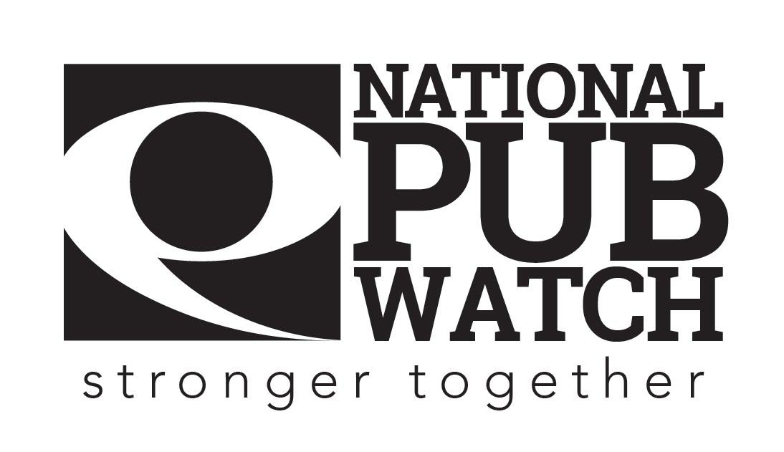
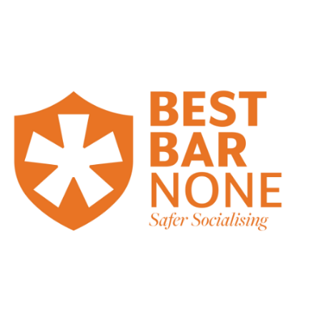

Discrimination Policy

Date Created:
Date of last review: NB Policies should be reviewed annually

Expected Standards
The Equality Act 2010 states that it is against the law to discriminate against anyone at their place of work or as a consumer because of their:
- age
- gender reassignment
- marriage or civil partnership
- pregnancy or maternity
- disability
- race including colour, nationality, ethnic or national origin
- religion or belief
- sex
- sexual orientation
These are called ‘protected characteristics’.

Discrimination can come in one of the following forms:
- direct discrimination - treating someone with a protected characteristic less favourably than others
- indirect discrimination - putting rules or arrangements in place that apply to everyone, but that put someone with a protected characteristic at an unfair disadvantage
- harassment - unwanted behaviour linked to a protected characteristic that violates someone’s dignity or creates an offensive environment for them
- victimisation - treating someone unfairly because they’ve complained about discrimination or harassment

It is not only our legal obligation to ensure that our team treat anyone working or socialising in our venue in accordance with this legislation, but also as a responsible operator it is important to us that all our staff and customers feel safe and welcome in the venue.

However, this legislation must be considered alongside our responsibility to maintain the licensing objectives:
- The prevention of crime and disorder
- Public safety
- The prevention of public nuisance
- The protection of children from harm
- Protecting and improving public health (Scotland only)

For example, it is against the law, to sell alcohol to an individual aged under 18 or to knowingly sell alcohol to someone who is drunk or appears to be drunk, or to knowingly allow disorderly conduct on relevant premises.

Common Law right to refuse service
Customers do not have the absolute right to seek entry or service in licensed premises. Service and/entry can be refused if the licensing objectives are likely to be undermined. For example, if an individual is underage (without valid ID).

Service and/entry may also be refused if an individual has previously been involved in incidents in the premises, or other premises, which are part of a Pubwatch scheme and they have been banned from those premises as a result.

The management will support members of staff who refuse service or exclude customers in such circumstances.

A decision to refuse service or exclude must never be taken purely as a result of the person’s protected characteristics.

If you have to refuse service or exclude a customer from the venue you should:
- Treat the person professionally and with courtesy
- Inform them clearly as to why you have refused service and/or excluded them
- If the person disputes the facts or refuses to leave the venue, then refer the matter to a senior member of staff or door staff
- As soon as possible, record the incident's circumstances in the venue’s ‘incident register’.
- Keep a record of witnesses to the incident so that they can be interviewed if necessary
- Secure any video recordings of the incident so they can be reviewed at a later date

Please sign this document to acknowledge that you have understood your responsibilities

Date: …………………………………………………………………

Trainer’s Name: ……………………………………………... Trainer’s Signature: …………………………………….

Trainee’s Name: …………………………………………….. Trainee’s Signature: ……………………………………

